|  |  |  |
| --- | --- | --- |
| **LAB 321 Assignment** | **Type:** | **Long Assignment** |
| **Code:** | **J3.L.P0011** |
| **LOC:** | **450** |
| **Slot(s):** | **15** |

**Title:** Blogging about my life

**Background**

A weblog (blog) is a website that contains a log or diary of information, specific topicss or opinions. Blogging has become one of the more popular pastimes on the internet. Some people blog for money, others blog about current events, and others blog for humor. The list goes on. Increasingly, bloggers use weblogs as a personal journal, preferring to keep it out of the spotlight. If you're someone who wants to start a personal blog, it's really quite easy. Try to finish this assignment with the help of mentors.

Reference site: <http://us-123my-life.simplesite.com/>

**Program Specifications**

Program a web blog to make your diary online, detail functions of this website is described below

**Features:**

This website contains 4 main functions

* Function 1 : Home page : ( see PIC 01 + PIC 02)
  + Display top 3 entry sort by published date
  + Each entry contains
    - Entry name
    - Description picture
    - Entry content
    - Published date
* Function 2 : Overview page ( see PIC 03)
  + Display all entry (title only) , sort by published date
* Function 3 : Entry detail ( see PIC 03)
  + Display entry detail
* Function 4 : Display about me page ( see PIC 03)

You do not need to write interface for admin control panel, you can add data manually (use SQL SERVER Management studio).

Note: All data must be load from database, not hard code in page.

***Expectation of User interface:***

Pic 01 : Home Page ( TOP)

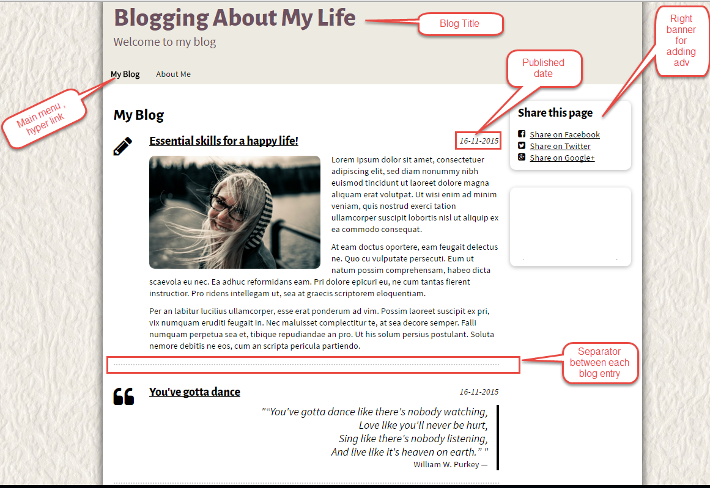

Pic 02 : The bottom of home page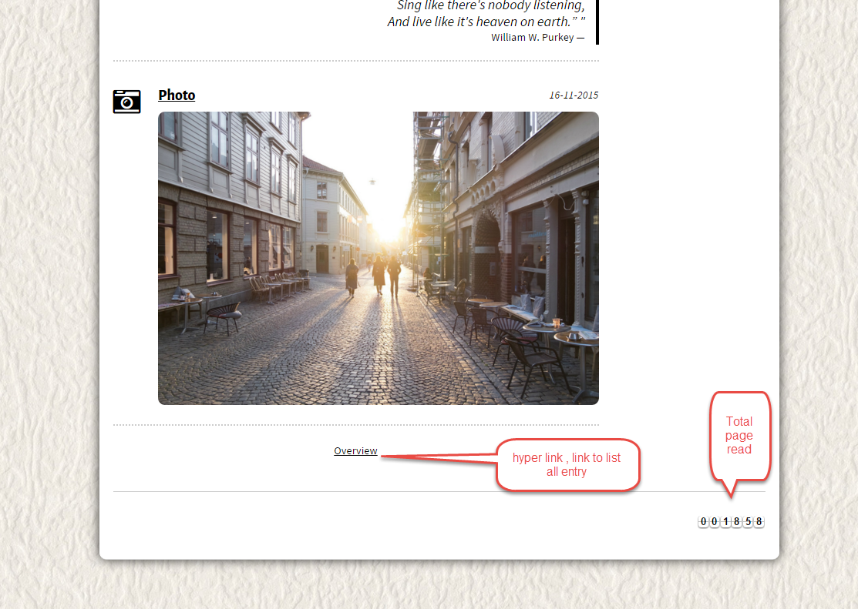

PIC 03 : Overview Page

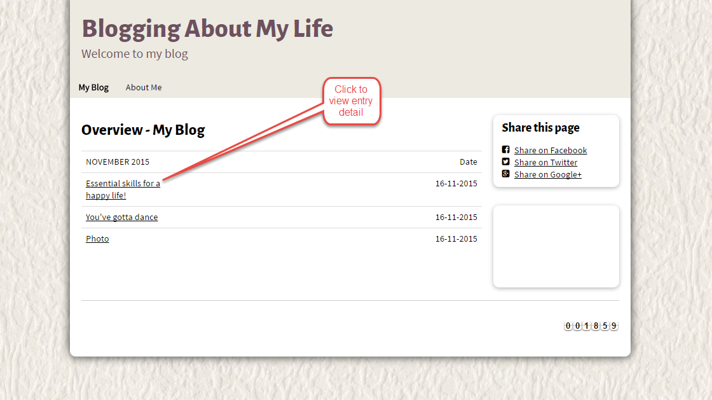

PIC 4 : Entry Detail

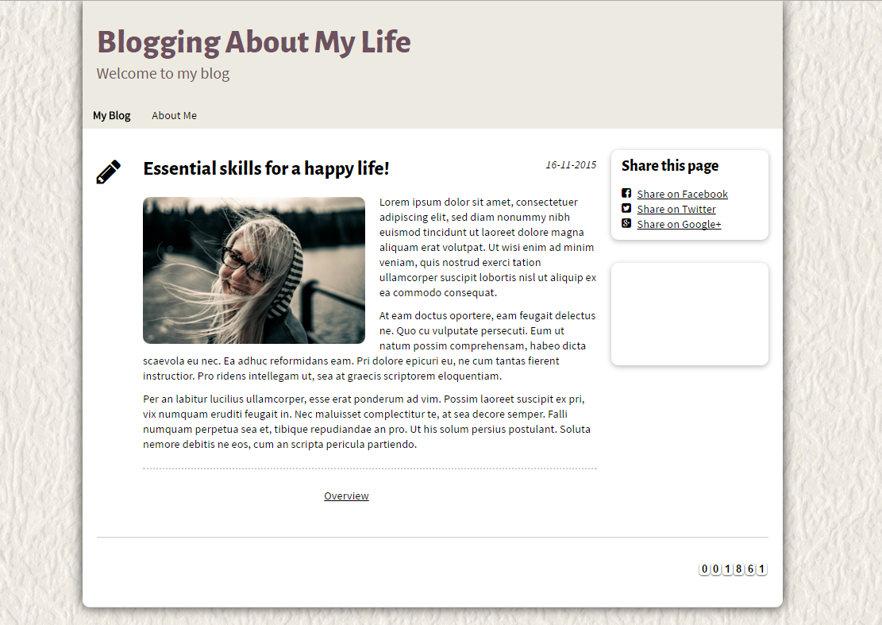

PIC 5 : About me Page

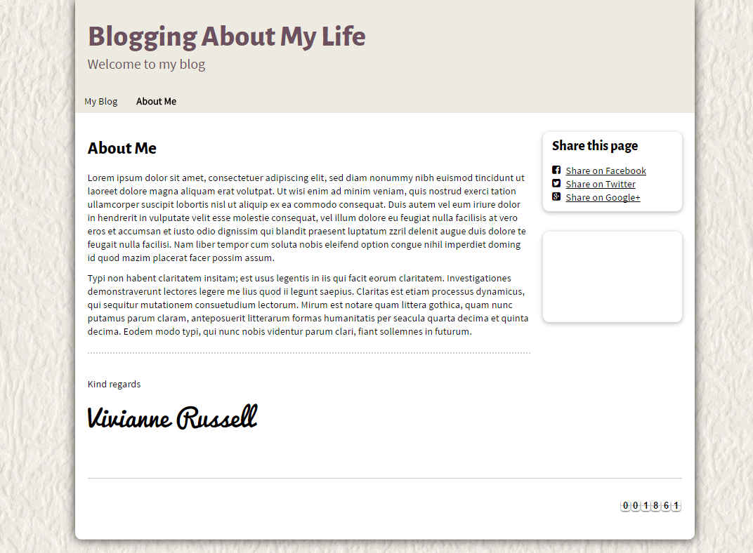

**Guidelines**

* Step 1 : Create web layout
* Step 2 : Create prototype
* Step 3 : Design database based on created prototype
* Step 4 : Code & Test